Light - 08
CLASS 10 - SCIENCE

 | Section A
 | Question No. 1 to 4 are based on the given text. Read the text carefully and answer the questions: Many optical instruments consist of a number of lenses. They are combined to increase the magnification and sharpness of the image. The net power (P) of the lenses placed in contact is given by the algebraic sum of the powers of the individual lenses P$​_{1}$ , P $​_{2}$ , P $​_{3}$ ... as P = P $​_{1}$ + P $​_{2}$ + P $​_{3}$ ... This is also termed as the simple additive property of the power of lens, widely used to design lens systems of cameras, microscopes and telescopes. These lens systems can have a combination of convex lenses and also concave lenses. | [4]
1 | What is the nature (convergent/divergent) of the combination of a convex lens of power + 4D and a concave lens of power - 2D?
2 | Calculate the focal length of a lens of power 2.5 D.
3 | Draw a ray diagram to show the nature and position of an image formed by a convex lens of power + 0.1 D, when an object is placed at a distance of 20 cm from its optical centre.
4 | How is a virtual image formed by a convex lens different from that formed by a concave lens? Under what conditions do a convex and a concave lens form virtual images?
 | Question No. 5 to 8 are based on the given text. Read the text carefully and answer the questions: The refraction of light on going from one medium to another takes place according to two laws which are known as the laws of refraction of light. These laws are  - The ratio of sine of the angle of incidence to the sine of the angle of refraction is always constant for the pair of media in contact.$\frac{sini}{sinr}=μ=$ constant This constant is called the refractive index of the second medium with respect to the first medium. The Refractive index is also defined as the ratio of the speed of light in a vacuum to the speed of light in the medium.  - The incident ray, refracted ray and normal all lie in the same plane. This law is called Snell’s law of refraction. | [4]
5 | When light travels from air to glass, which is greaterthe angle of incidence and the angle of refraction?
6 | What is the refractive index of the second medium with respect to the first medium, when the angle of incidence is 45° and the angle of refraction is 30° as light travels from air to the second medium?
7 | If the refractive index of glass is 1.5 and speed of light in air is 3$×$ 10 $​^{8}$ m/s. what is the speed of light in glass?
8 | If the refractive index of material awith respect to material bis 2, what is the refractive index of material bwith respect to material a?
 | Question No. 9 to 12 are based on the given text. Read the text carefully and answer the questions: Hold a concave mirror in your hand and direct its reflecting surface towards the sun. Direct the light reflected by the mirror on to a white card - board held close to the mirror. Move the card - board back and forth gradually until you find a bright, sharp spot of light on the board. This spot of light is the image of the sun on the sheet of paper; which is also termed as Principal Focus of the concave mirror. 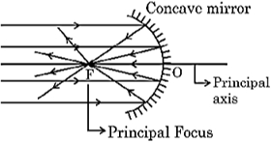 | [4]
9 | List two applications of concave mirror.
10 | If the distance between the mirror and the principal focus is 15 cm, find the radius of curvature of the mirror.
11 | Draw a ray diagram to show the type of image formed when an object is placed between pole and focus of a concave mirror.
12 | An object 10 cm in size is placed at 100 cm in front of a concave mirror. If its image is formed at the same point where the object is located, find:  - focal length of the mirror, and  - magnification of the image formed with sign as per Cartesian sign convention.
 | Question No. 13 to 16 are based on the given text. Read the text carefully and answer the questions: The relationship between the distance of the object from the lens (u), a distance of the image from the lens (v) and the focal length (f) of the lens is called the lens formula. It can be written as$\frac{1}{f}=\frac{1}{v}−\frac{1}{u}$ . The size of the image formed by a lens depends on the position of the object from the lens. A lens of short focal length has more power whereas a lens of long focal length has less power. When the lens is convex, the power is positive and for the concave lens, the power is negative. The magnification produced by a lens is the ratio of the height of the image to the height of the object as the size of the image relative to the object is given by linear magnification (m). When m is negative, an image formed is real and when m is positive, an image formed is virtual. If m < 1, the size of the image is smaller than the object. If m >1, the size of the image is larger than the object. | [4]
13 | An object with a height of 4 cm is positioned 10 cm away from a convex lens with a focal length of 20 cm. Determine the position of the image formed by the lens.
14 | Given an object of height 4 cm positioned at a distance of 10 cm from a convex lens with a focal length of 20 cm, what is the height or size of the resulting image formed by the lens?
15 | If a convex lens forms an image with a magnification of - 2 and the height of the image is 6 cm, what is the height of the object?
16 | What is the power of a concave lens with a focal length of 5 cm?
 | Section B
17 | State True or False:  - Magnification is expressed as the ratio of the height of the image to the height of the object.  - Concavemirrors are fitted on the sides of the vehicle, enabling the driver to see traffic behind him/her to facilitate safe driving.  - For spherical mirrors of small apertures, the radius of curvature is found to be equal to twice the focal length.  - The angle between the incidence of rays and normal at the point of incidence is called the angle of incidence.  - The principal axis of a lens is a straight line passing through its two centres of curvature.  - Light travels the fastest in a vacuum with the highest speed of 3$×$ 10 $​^{8}$ ms $​^{−1}$ .  - The central point of the lens is known as its optical center.  - The pole of a spherical mirror is represented by the letter P.  - The SI unit of power of a lens is Newton.  - The incident ray, the normal to the surface at the point of incidence and the reflected ray, all lie in the same plane.  - According to the New Cartesian Sign Convention, the object is always placed to the left of the mirror.  - The phenomenon of change in the path of a beam of light as it passes from one medium to another is called the refraction of light.  - ​​A highly polished surfacereflects most of the light falling on it.  - The mirror in which the reflecting surface is curved outwards is called the convex or diverging mirror.  - The principal focus of a convex lens is a point on its principal axis to which light rays parallel to the principal axis converge after passing through the lens.  - Refraction is the phenomenon of bouncing back of light into the same medium on striking the surface of any object.  - Concave mirrors are often used as shaving mirrors to see a larger image of the face.  - The centre of curvature of a concave mirror lies in front of it.  - The absolute refractive index of a medium is simply called its refractive index.  - A transparent material bound by two surfaces, of which one or both surfaces are spherical, forms a lens. | [20]
 | Section C
18 | Fill in the blanks:  - The phenomenon of change in the path of a beam of light as it passes from one medium to another is called ________ of light.  - The concave lens is known as ________ lens.  - The ________ of a lens is a straight line passing through its two centres of curvature.  - ________ of substance is the ratio of the speed of light in a vacuum to the speed of light in a medium.  - ________ of a lens is the reciprocal of the focal length of the lens.  - The angle between the incidence of rays and ________at the point of incidence is called the angle of incidence.  - According to the new cartesian sign convention, the object is always placed to the ________ of the mirror.  - ________ is expressed as the ratio of the height of the image to the height of the object.  - The central point of the lens is known as its ________.  - If we look into a pool of water, it appears to be ________ deep than it really is.  - ________ is the phenomenon of bouncing back of light into the same medium on striking the surface of any object.  - The cause of refraction is the change in the ________ of light as it goes from one medium to another.  - The dentists use ________ mirrors to see large images of the teeth of patients.  - While going from a rarer to a denser medium, the ray of light bends ________ the normal.  - A ________ sign in the value of the magnification indicates that the image is real.  - A positive sign in the value of the magnification indicates that the image is ________.  - The second law of reflection is also known as ________ law.  - The SI unit of power of a lens is ________. | [18]
 | Section D
19 | Match the following with the correct response : 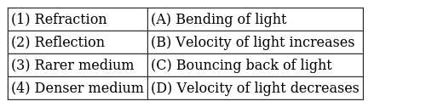  a) 1 - D, 2 - A, 3 - C, 4 - B  b) 1 - A, 2 - C, 3 - B, 4 - D  c) 1 - C, 2 - B, 3 - D, 4 - A  d) 1 - B, 2 - D, 3 - A, 4 - C | [1]
20 | Match the following with the correct response : 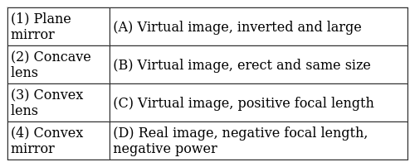  a) 1 - B, 2 - D, 3 - A, 4 - C  b) 1 - C, 2 - B, 3 - D, 4 - A  c) 1 - A, 2 - C, 3 - B, 4 - D  d) 1 - D, 2 - A, 3 - C, 4 - B | [1]
21 | Match the following with the correct response : 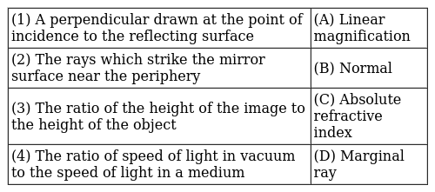  a) 1 - C, 2 - B, 3 - D, 4 - A  b) 1 - D, 2 - A, 3 - C, 4 - B  c) 1 - B, 2 - D, 3 - A, 4 - C  d) 1 - A, 2 - C, 3 - B, 4 - D | [1]
22 | Match the following with the correct response : 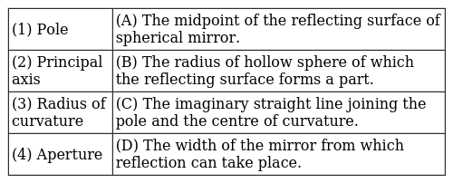  a) 1 - A, 2 - C, 3 - B, 4 - D  b) 1 - C, 2 - B, 3 - D, 4 - A  c) 1 - B, 2 - D, 3 - A, 4 - C  d) 1 - D, 2 - A, 3 - C, 4 - B | [1]
23 | Match the following with the correct response : 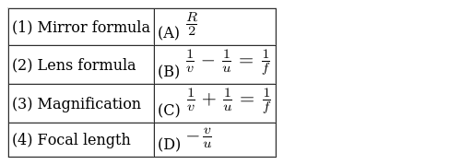  a) 1 - C, 2 - B, 3 - D, 4 - A  b) 1 - A, 2 - C, 3 - B, 4 - D  c) 1 - D, 2 - A, 3 - C, 4 - B  d) 1 - B, 2 - D, 3 - A, 4 - C | [1]
24 | Match the following with the correct response : 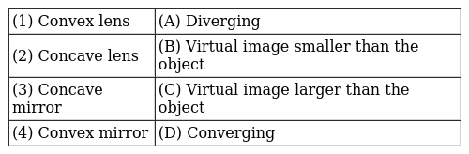  a) 1 - A, 2 - C, 3 - B, 4 - D  b) 1 - D, 2 - A, 3 - C, 4 - B  c) 1 - C, 2 - B, 3 - D, 4 - A  d) 1 - B, 2 - D, 3 - A, 4 - C | [1]
25 | Match the following with the correct response : 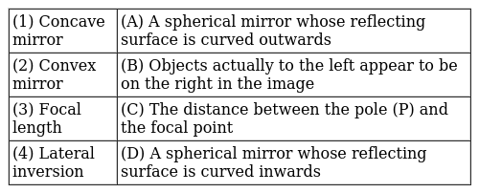  a) 1 - C, 2 - B, 3 - D, 4 - A  b) 1 - A, 2 - C, 3 - B, 4 - D  c) 1 - D, 2 - A, 3 - C, 4 - B  d) 1 - B, 2 - D, 3 - A, 4 - C | [1]
26 | Match the following with the correct response : 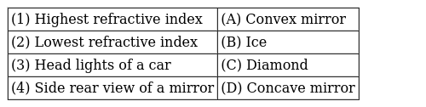  a) 1 - C, 2 - B, 3 - D, 4 - A  b) 1 - A, 2 - C, 3 - B, 4 - D  c) 1 - D, 2 - A, 3 - C, 4 - B  d) 1 - B, 2 - D, 3 - A, 4 - C | [1]
 | Section E
27 | In an experiment to determine the focal length of a convex lens, a student obtained the image of a distant window on the screen. To determine the focal length of the lens, she should measure the distance between the _____.  a) None of these  b) lens and the window only  c) lens and screen only  d) screen and the window only | [1]
28 | When a lemon kept in water in a bowl is viewed from outside, it appears ________ than its actual size.  a) None of these  b) Smaller  c) Larger  d) Same | [1]
29 | Magnification produced by a rearview mirror fitted in vehicles ________.  a) equal to 1  b) greater than 1  c) none of these  d) less than 1 | [1]
 | Section F
30 | Given below are few steps (not in proper sequence) followed in the determination of the focal length of a given convex lens by obtaining a sharp image of a distant object:  - Measure the distance between the lens and screen  - Adjust the position of the lens to form a sharp image  - Select a suitable distant object  - Hold the lens between the object and the screen with its faces parallel to the screen  The correct sequences of steps for determination of focal length are:  a) C, D, B, A  b) C, A, B, D  c) A, B, C, D  d) C, A, D, B | [1]
 | Section G
31 | Statement I - A real image is always inverted. Statement II - A virtual image is always erect.  a) Both statements are correct.  b) Both statements are wrong.  c) Statement I is true.  d) Statement II is true. | [1]
 | Section H
32 | Read the following and answer any four questions: While dealing with the reflection of light by spherical mirror set of sign convention is followed. In this convention, the pole (P) of the mirror is taken as the origin. The object is placed to the left of the mirror. All distance measured to the right of the origin is taken positively. Distance to the left is measured negative. All distance parallel to the principle is measured from the pole. 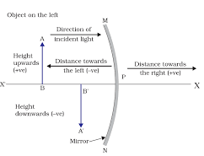  - Linear magnification produced by a concave mirror may be  - less than 1 or equal to 1  - more than 1 or equal to 1  - less than 1, more than 1 or equal to 1  - less than 1 or more than 1  - Magnification produced by a plane mirror  - less than one  - greater than one  - zero  - equal to one  - If the magnification of - 1 is to be obtained by using a converging mirror, then the object has to be placed  - between pole and focus  - at the centre of curvature  - beyond the centre of curvature  - at infinity  - The ratio of the height of an image to the height of an object known as  - magnification  - lateral displacement  - refractive index  - none of the above  - If the magnification has a plus sign then the image is ________ and ________.  - virtual; erect  - real; erect  - virtual; inverted  - real; inverted | [4]
33 | Read the following and answer any four questions: In the refraction of light through a rectangular glass slab, the light ray changes its direction at the point O and O’ and at O’ the light ray has entered from glass to air bend away from the normal. The emergent ray is parallel to the incident ray. The incident ray, the refracted ray and the normal to interface of two transparent media at the point of incidence, all lie in the same line. 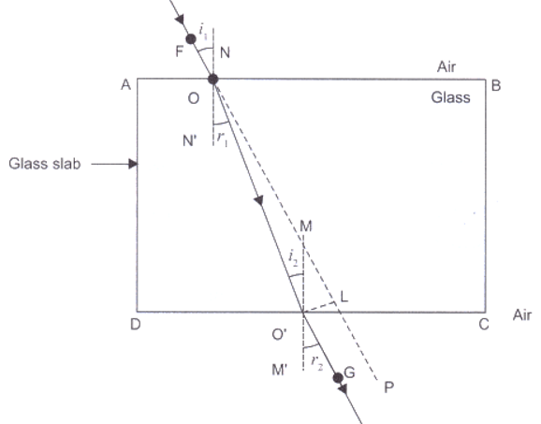  - A ray of light passes from glass to air then an emergent ray is  - parallel to incidence ray  - perpendicular to incidence ray  - oblique to incidence ray  - inclined to incidence ray  - A ray of light is travelling from denser medium to rarer medium along the normal  - refracted toward the normal  - refracted away from the normal  - goes along the boundaries  - is not refracted  - The ray of light bends toward the normal while passing  - from denser to rarer medium  - from rarer to denser medium  - from denser to rarer medium  - from rarer to rarer medium  - In which material light ray travel faster  - air  - glass  - both (a) and (b)  - none of the above  - Glass has a ________ index of refraction from air  - equal  - greater  - smaller  - impossible to say | [4]
34 | Read the following and answer any four questions: When the ray of light travels from 1 transparent medium to another it will change the direction in the second medium. The extent of change in direction that takes place in a pair of mediums is expressed in terms of the refractive index. The value of the refractive index for a given pair of medium depends upon the speed of light in the second medium.  - The refractive index of 4 substance P, Q, R and S are 1.50, 1.36. 1.77 and 1.31 respectively. The speed of light is maximum in the substance:  - P  - Q  - R  - S  - If medium 1 is in a vacuum then the refractive index of medium 2 is considered with respect to it is called ________.  - absolute refractive index  - refractive index  - magnification  - none of the above  - The Refractive index of water is  - 1.33  - 1.50  - 2.42  - 1.36  - The speed of light in airis ________  - 3$×$ 10 $​^{8}$ m/s  - 3$×$ 10 $​^{7}$ mm/s  - 3$×$ 10 $​^{10}$ cm/s  - 3$×$ 10 $​^{6}$ km/s  - The Refractive index of quartz is ________ than/to alcohol.  - less  - more  - equal  - cannot be compared | [4]
35 | Read the following and answer any four questions: In the concave mirror,the nature,position and size of the image formed dependon the position of the object in relation to pole, the centre of curvature and focus. The image is real for some position of the object and virtual for another position. The image is either magnified, reduced, or has the same size, depending on the object’s position.  - What will be the position of the image if the objectis placed at infinity?  - Beyond C  - Between F and C  - At infinity  - At the focus F  - For an image to be the same size as the objectwhat will be the position of the object?  - At F  - At C  - Between C and F  - Beyond C  - If the image formed behind a concave mirror what will be the nature of the image?  - Virtual  - Erect  - Both (a) and (b)  - none of the above  - Highly diminished point - size image is formed  - At the focus F  - At infinity  - Behind the mirror  - At C  - If the object is placed at F size of the image is ________  - Same size  - Enlarged  - Highly enlarged  - Diminished | [4]
36 | Read the following and answer any four questions: A transparent materialbound by 2 surfaces of which one or both surfaces are spherical, forms a lens may have 2 spherical surfaces, bulging outward or curved inward. Such a lens is called the double concave or convex lens. Alens may be a convex lens or a concave lens. The centre of curvature usually represents by letter C $​_{1}$ andC $​_{2}$ . If parallel rays are passed from the opposite surface of lens another principle focus on the opposite is observed.  - A diverging lens is used in:  - a magnifying glass  - a car to see an object on the rear side  - spectacles for correction of short sight  - a simple camera  - When an object is kept at any distance in front of a concave lens, the image formed is always:  - virtual, erect and magnified  - virtual, erect and diminished  - virtual, inverted and diminished  - virtual, erect and same size of the object  - Which of the following can form a virtual image which is always smaller than the object?  - a concave lens  - a convexlens  - a plane mirror  - a concave mirror  - The distance of principle focus from the optical centre of the lensis called:  - centre of curvature  - focal length  - pole  - principle focus  - A convex lens ________ray of light, while a concave lens is ________ray of light.  - converges,diverges  - diverge in both  - converge in both  - diverges,converges | [4]

